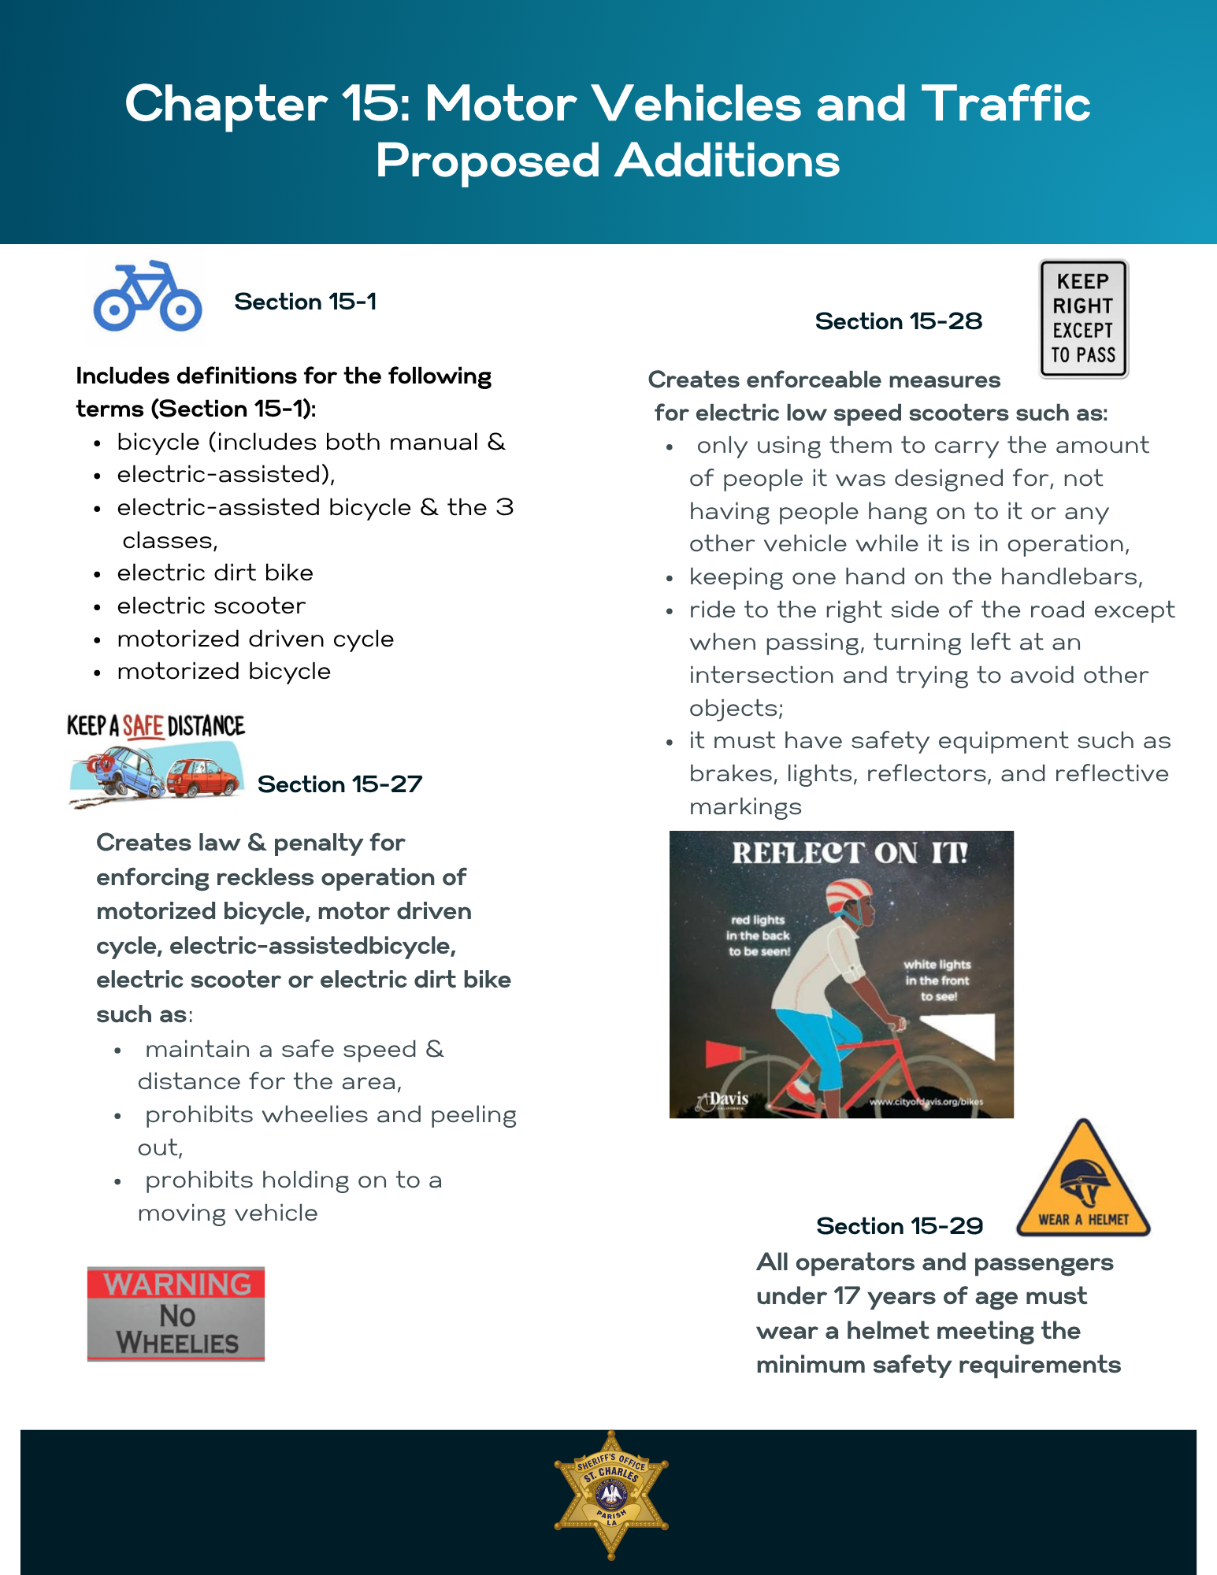
Note: This is not finalized until approved
by the Parish Council
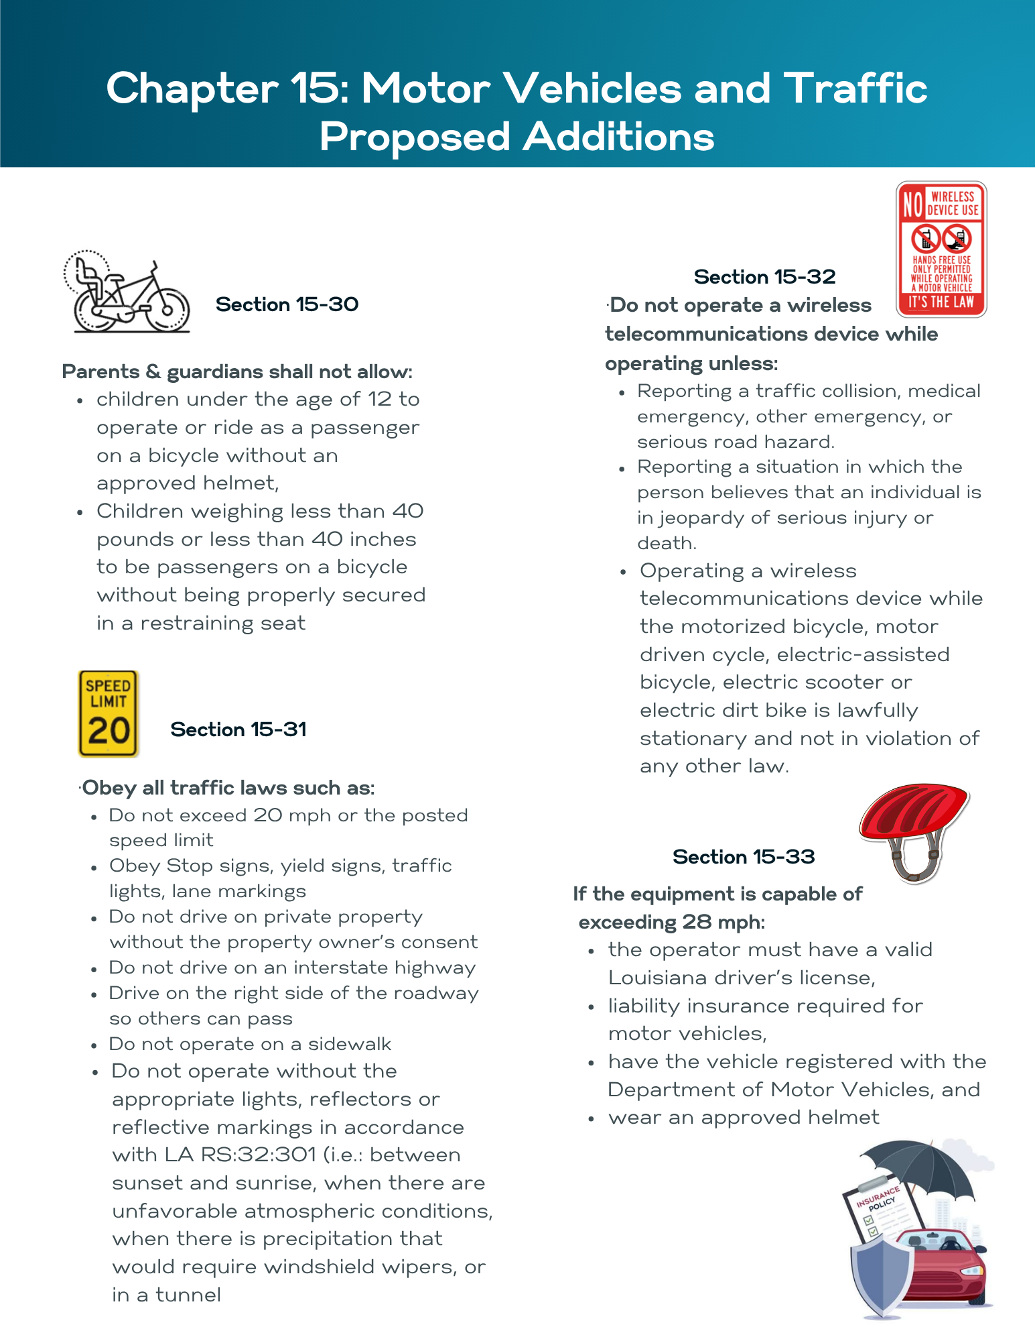
Note: This is not finalized until approved
by the Parish Council

