Certificate of
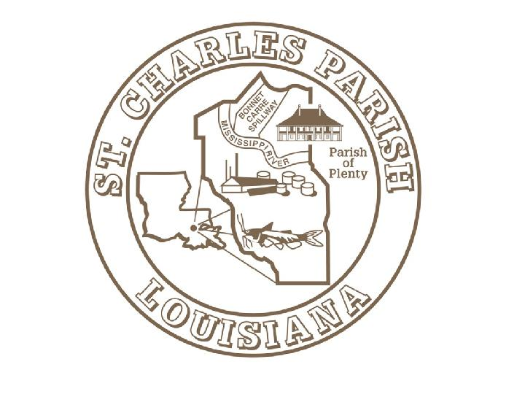
Achievement

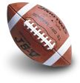
St. Charles Parish

Recognizes

for being named

Desmond J. Hilaire, Council Chairman Albert D. Laque, Parish President

