PZHO-2011-16 requested by Brent A. Desselle for special permission to operate the following home occupation – “B. A. Desselle Trim Contractor, Inc.” – a carpenter. The home office will be at 212 West Easy Street, Destrehan, La. Zoning District R-1A. Council District 6. Ms. Stein.

Ms. Stein: Thank you Mr. Chair. The application is largely the same type of business as Mr. Hammill’s business but it comes to the Commission for slightly a different reason so the report is a little bit longer and we’re recommending approval with stipulations, so we ask that if you are amendable to the stipulations that you vote twice. Once on whether or not to approve with the stipulations and then whether or not to approve.

Mr. Booth: Ok.

Ms. Stein: Mr. Desselle completed an application to use his residence, 212 West Easy Street, owned by his son since April 2006, as the domicile for B. A. Desselle Trim Contractor, Inc, a woodworker and trim carpenter incorporated in 1983 and domiciled outside the Parish. When Mr. Desselle moved to West Easy Street, the business appeared to remain domiciled outside the Parish. The Secretary of State records are not extremely clear when it moved.

In 2008 Code Enforcement responded to a complaint that a new building on the site was being used for a cabinet business (id 45026). The building had been permitted as a 3600 sq. ft. “residential storage building” (permit 21382-08). The complaint was closed under the conclusion that no business activity was occurring.

The complaint was recently made again (id 48889; information below). Information from our database is included in the report there and we also have a few pictures of the site in the report.

Date | Log Ini. | Ins. Ini | On Site? | Inspection Finding
9/9/2011 | PD | KL | -1 | Spoke to Ms. Deselle at site. She stated she has applied for P&Z home occupation and she is awaiting for us to deliver her sign to post. Confirmed with Rechelle that the Deselles have applied, but they have to go in front of the board sometime in November.
8/30/2011 | PD | KL | -1 | Inspector dropped off a home occupation ($200) application to Ms. Fay Deselle. She will get the application filled out and back to us.
8/29/2011 | PD | KL | -1 | Spoke to Mr. Brent Deselle. He stated that he does have a trim carpeting business, but insists he does not do any of the work from home. He does the work at his clients locations only. Mr. Deselle stated he does not work late at night. He works alone and has no employees and he does not receive any lumber or have any equipment delivered to his home or garage that he works out of. It was explained to Mr. Deselle by the inspector, that a home occupation permit is necessary to do paperwork, receive mail, etc. at 212 W. Easy Street. Mr. Deselle will comply and get a permit. Mr. Deselle stated that the dumpster trailer that he has on the property, was purchased and used for trash hauling after Katrina, but he does not use it for that purpose. He uses it occasionally when he trims large tree branches.
8/26/2011 | PD | PD | 0 | A complaint was received over the website about a massive warehouse built in a residential area, with a cabinet business being run.

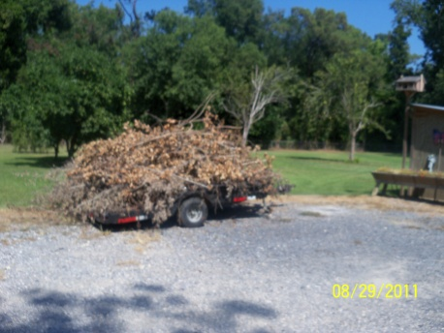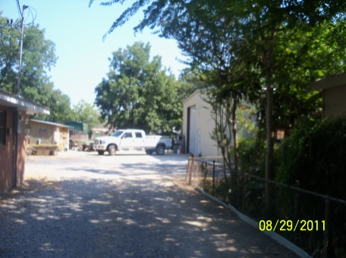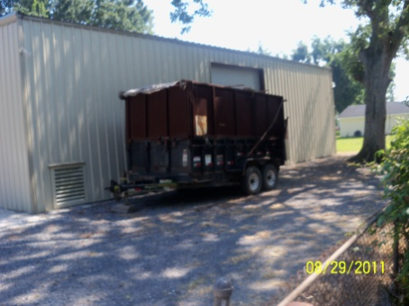

The Desselles assert that the tree cutting that has been mentioned that’s associated with the business occurs only on their own property; they have has been advised that tree service will not be permitted under this home occupation. Section 3808 of The Louisiana Horticulture Commission requires arborists to be licensed; the Desselles have no intention of providing tree services.

Today, the Secretary of State’s online corporation’s database shows that B. A. Desselle Contractor, Inc. is domiciled at the residence (following page). The request appears before the Planning and Zoning Commission because of the need for registration with the Louisiana State Licensing Board for Contractors when the value of any home improvement job exceeds $7500.
We do recommend approval of the application with the following stipulations -

1. No deliveries to the residence. The applicant has stated that the business operates with materials delivered to the site of work.
2. No outdoor storage of materials, equipment, or waste associated with the business be permitted with the home occupation and that’s kind of a reiteration of the operational guidelines of a home occupation and we just want to make sure that’s extremely clear to everybody.

The need for additional stipulations may become apparent at the public hearing since this application is here as the result of a complaint. So we ask that you would come back to us after we hear from the public.

Mr. Booth: Thank you. This is a public hearing for PZHO-2011-16 for Brent Desselle for permission to have a home occupation Brent Desselle Trim Contractor, Inc. 212 West Easy Street in Destrehan. Is there anyone here to speak in favor of this application? If you can state your name and address for the record.

My name is Barny Desselle, I live at 212 West Easy Street, New Sarpy. My backyard and his backyard are adjacent. I wouldn’t even know if he was back there. He keeps the place nice and neat, it’s a beautiful facility. The tree situation, the trees were hanging, bamboo. There was no tree cutting service situation.

Mr. Booth: Is there anyone here to speak in favor? State your name and address from the record please.

Malcolm Trosclair, 125 Van’s Lane, Destrehan. My back yard and his backyard adjoins. I have no problem with his shop. As a matter of fact you don’t even hear him when he working in there.

Mr. Booth: Is there anyone else here to speak in favor? Is the applicant here tonight? Could you come up?

Brent Desselle, B.A. Desselle Contractor.

Mr. Booth: We have these stipulations we just want to make sure that you have not problems with them. No deliveries as you’ve already heard, and no outside storage of materials, equipment and waste from the business. That’s no problem for you?

Mr. Desselle: No problem.

Mr. Booth: Ok good. Is there anything you’d like to say about the business?

Mr. Desselle: Just briefly I’ve been there for 4 years now and had the new shop was originally built as a storage building. I do minor cabinet work for different contractors. There are no customers who pull in my yard whatsoever, no street signs or anything like that. It’s a very safe place to work. I’m by myself, no employees.

Mr. Booth: Thank you. Anyone else here to speak in favor of the application? Anyone here to speak in opposition of this application, please step forward. Seeing none, we’ll close the public hearing.

Mr. Perry: Mr. Chairman, this application is from my district, District 6. I’ve driven pass the location and it appears to be in very good shape and I have no problem with this particular application.

Mr. Booth: Thank you Mr. Perry. Are there any other questions or comments from anyone? Ok, let’s cast our vote on this matter.

YEAS: Pierre, Gibbs, Booth, Perry Clulee
NAYS: None
ABSENT: Galliano, Foster

Mr. Booth: That’s unanimous for those who are here tonight. Mr. Foster and Mr. Galliano are not here tonight. You’ll need to come to this room on November 7th. The Council will bring this same issue up and you will ask them for approval and that will be the final approval. Thank you for coming Sir.

