St. Charles Parish
Department of Planning & Zoning

Land Use Report
Case Number: HO 2011-16

GENERAL APPLICATION INFORMATION
- Name/Address of Applicant: Application Date: 9/1/2011
Brent A. Desselle
212 West Easy Street
Destrehan 70047
(h) 504.487.9165 (c) 504.884.0996
No email given

- Name of Business
B. A. Desselle Trim Contractor, Inc.

- Applicant’s description of business:
B. A. Desselle Trim Contractor is a small one man run business with no employees. I will only use this shop to construct cabinets, entertainment centers, shutters, mantels or anything else my contractors ask me to build out of wood. One white F-350 truck will travel through the driveway. No customers, sales or services will be implemented on the property of 212 West Easy. Additionally, no signs or advertisements will be seen on the premises. No deliveries will be received, except what I bring with my truck, at 212 West Easy. Deliveries will be made per my truck to job sites. At these job sites will be where all sales will be rendered. Only the construction of the above named items will be made at this location. This building will be used for only shop purposes. I am a 60 year old man who conducts odd and end jobs for local contractors. Please contact me with further questions (504.884.0996).

SITE – SPECIFIC INFORMATION
- Existing Land Use and Zoning:
Single-family residence in an R-1A zoning district.

- Surrounding Land Uses and Zoning:
The site is surrounded by single-family residences with R-1A zoning in the front and sides and OL zoning to the rear.

- Traffic Access and parking:
In 2008, the property was resubdivided into a zig-zag-shaped lot in order to permit a 40’ x 60’ “residential storage” building and a long, wide access hard-surfaced driveway. Eight or more passenger vehicles could park on the property.

APPLICABLE REGULATIONS
Regulations for Home Occupations: Appendix A. Section XXII
B. Permit Process:
1. Pre-Application Orientation: The Planning Director, or his designated staff, shall advise citizens of the regulations for home occupations such as appropriate activities for home occupations, operational regulations, and consequences for violating operational regulations. The Planning Director, or his designated staff, shall determine whether the premises to be permitted is in compliance with the St. Charles Parish code of Ordinances, or what measures must be taken to bring the premises into compliance prior to consideration of an application for a home occupation permit.
2. Application: A citizen who proposes appropriate activities at a residence that is not under citation for violation of this Code may apply for a permit for a home occupation. The fee shall be two hundred dollars ($200.00). The applicant will agree to follow operational regulations. When an applicant does not own the subject property, the applicant must provide notarized endorsement of the application by the property owner.
3. Departmental Review: The Planning Director, or his designated staff, shall determine whether the proposed activity complies with the operational regulations of this section. The operational regulations are a guideline.
4. Public Notice and Comment:
a. Once the Planning Director has determined that the proposed activity meets the general parameters of this code and the operational requirements of this section, the property shall be posted for ten (10) days with a sign stating that the resident has applied for a permit to operate a home occupation and that the Department of Planning and Zoning will receive and record public comment on the application for the same ten (10) calendar days.
b. A copy of the application shall be forwarded to the District Councilman and both Councilman-At-Large.
5. Determination: The Planning Director shall consider the nature of the home occupation, the operational regulations, the relationship of the proposed home occupation to neighboring properties, requirements for state permits and licenses, and take one of the following actions:
a. Issue a Home Occupational Permit with or without written conditions, for those occupations that do not require state permit or license.
b. Forward applications requiring state permits or licenses along with a recommendation of the Department to the Planning and Zoning Commission for public hearing and recommendation and to the Parish Council for public hearing and decision.
c. Deny the application.
C. Operational Regulations:
1. All products produced for sale must be hand manufactured or grown on the premises using only hand tools or domestic mechanical equipment. Such domestic mechanical equipment shall not exceed two (2) horsepower per piece of equipment, and the sum total of all such equipment shall not exceed six (6) horsepower. A single kiln shall not exceed eight (8) kilowatts or the equivalent in a gas-fired fixture.
2. All sales of products, including those produced or grown on the premises, and the performance of all services shall take place off the premises. However, the Planning Director may permit on-premises sales or the performance of services as a condition of a home occupation permit when it may be found that such sales or services will not produce any detrimental effects upon the surrounding neighborhood. This may include but is not limited to snowball stands, tax and legal services. The Department may impose conditions regulating the duration, scope, and size of operation.
3. There shall be no signs posted which indicate the existence of the home occupation.
4. No licensed vehicle in excess of one (1) ton (manufacturer's rating), and no more than one (1) licensed motorized vehicle, shall be utilized by any resident of the premises in connection with the home occupation. (Ord. No. 03-8-11, § I, 8-18-03)
5. Only the residents of the premises shall be engaged in the home occupation.
6. There shall be no outdoor storage of materials or products on the premises except as otherwise permitted by the Planning Director. Indoor storage of material or products shall not exceed twenty (20) percent of the gross floor area of the dwelling.
7. Home occupations, except for horticultural uses, shall be conducted only within a structure on the premises.
8. The home occupation shall not eliminate required off-street parking.
9. The home occupation shall not cause any external effect associated with the home occupation, such as increased noise, excessive traffic, excessive lighting, or offensive odor, which is incompatible with the characteristics of the residential zone, or in violation of the revisions of any applicable governmental code. There shall be no illegal discharge of materials, fluids, or gases into the sewer system, or any other manner of discharging such items in violation of any applicable governmental code.
10. The resident or residents engaged in the home occupation shall possess a current St. Charles Parish Occupational License and health certification from the Parish Health Unit when required. An inspection approval from the State Fire Marshal shall be required when any food preparation requiring ovens or stoves, mechanical equipment, a simple kiln, or gas-fired fixture are necessary for production.
11. Home occupation activities which include the manufacture, sale, or repair firearms (or any related commercial activity) shall be prohibited in R-2 and R-3 residential zoning districts, and shall be additionally prohibited on residentially zoned lots which contain more than one dwelling unit. (Ord. No. 96-7-4, 96-7-4)
12. No alcoholic beverages shall be sold or provided in connection with the operation of a home occupation. (Ord. No. 98-8-1, 8-3-98)
13. Home occupation permit holders shall provide annual evidence of valid occupational licensing as issued by the St. Charles Parish Sheriff's Office. Evidence of occupational licensing shall be provided to the Department of Planning and Zoning by March 31st of each calendar year. (Ord. No. 98-8-14, 8-17-98)

FINDINGS
Mr. Desselle completed an application to use his residence, 212 West Easy Street, owned by his son since April 2006, as the domicile for B. A. Desselle Trim Contractor, Inc, a woodworker and trim carpenter incorporated in 1983 and domiciled outside the Parish. When Mr. Desselle moved to West Easy Street, the business appeared to remain domiciled outside the Parish.

In 2008 Code Enforcement responded to a complaint that a new building on the site was being used for a cabinet business (id 45026). The building had been permitted as a 3600 sq. ft. “residential storage building” (permit 21382-08). The complaint was closed under the conclusion that no business activity was occurring.

The complaint was recently made again (id 48889; information below).

Date | Log Ini. | Ins. Ini | On Site? | Inspection Finding
9/9/2011 | PD | KL | -1 | Spoke to Ms. Deselle at site. She stated she has applied for P&Z home occupation and she is awaiting for us to deliver her sign to post. Confirmed with Rechelle that the Deselles have applied, but they have to go in front of the board sometime in November.
8/30/2011 | PD | KL | -1 | Inspector dropped off a home occupation ($200) application to Ms. Fay Deselle. She will get the application filled out and back to us.
8/29/2011 | PD | KL | -1 | Spoke to Mr. Brent Deselle. He stated that he does have a trim carpeting business, but insists he does not do any of the work from home. He does the work at his clients locations only. Mr. Deselle stated he does not work late at night. He works alone and has no employees and he does not receive any lumber or have any equipment delivered to his home or garage that he works out of. It was explained to Mr. Deselle by the inspector, that a home occupation permit is necessary to do paperwork, receive mail, etc. at 212 W. Easy Street. Mr. Deselle will comply and get a permit. Mr. Deselle stated that the dumpster trailer that he has on the property, was purchased and used for trash hauling after Katrina, but he does not use it for that purpose. He uses it occasionally when he trims large tree branches.
8/26/2011 | PD | PD | 0 | A complaint was received over the website about a massive warehouse built in a residential area, with a cabinet business being run.

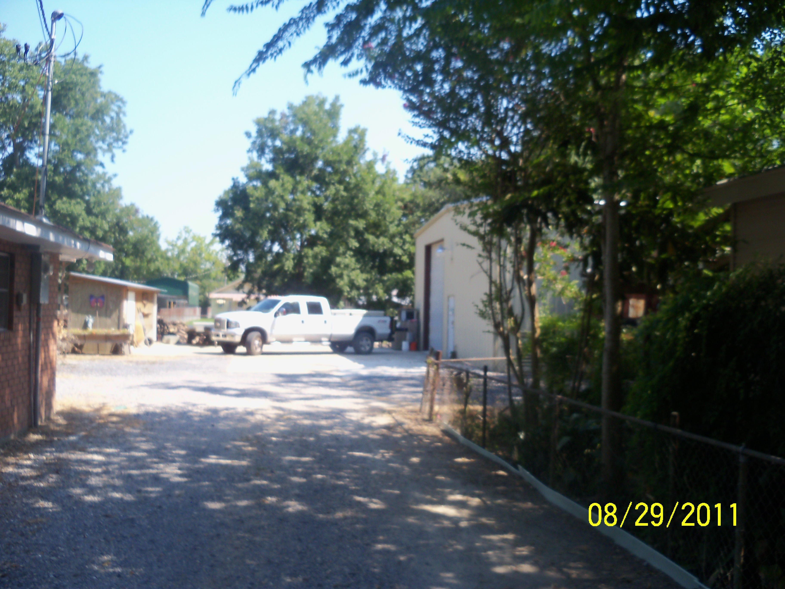

The Desselles assert that the tree cutting mentioned on the 29th occurs only on their own property; they have has been advised that tree service will not be permitted under this home occupation. Section 3808 of The Louisiana Horticulture Commission requires arborists to be licensed; the Desselles have no intention of providing tree services.

Today, the Secretary of State’s online corporation’s database shows that B. A. Desselle Contractor, Inc. is domiciled at the residence (following page). The request appears before the Planning and Zoning Commission because of the need for registration with the Louisiana State Licensing Board for Contractors when the value of any home improvement job exceeds $7400.

DEPARTMENT RECOMMENDATIONS
APPROVAL with the following STIPULATIONS:
1. No deliveries to the residence.
2. No outdoor storage of materials, equipment, or waste associated with the business.

The need for additional stipulations may become apparent at the public hearing.

